

3 6 3



3 3 3 3



5 7



3 6 3



4 4 4



4 4 4

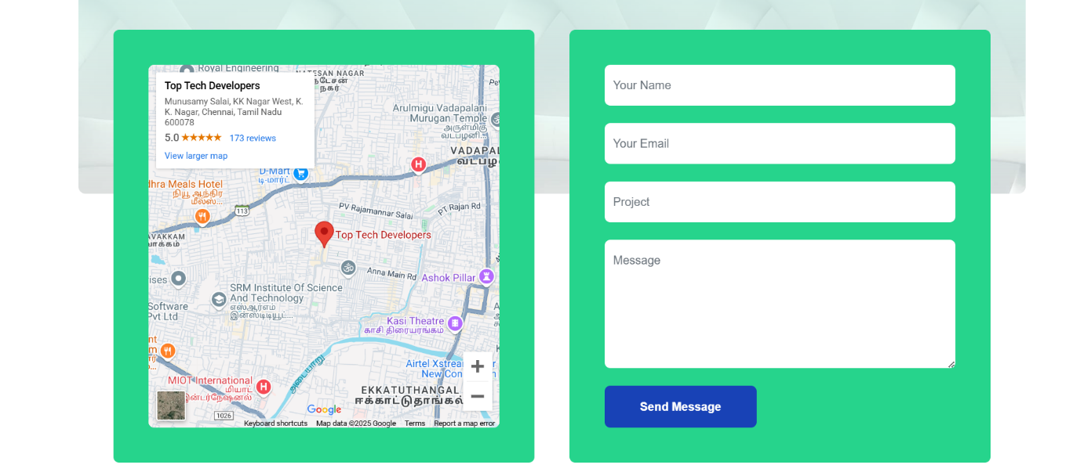

1 5 5 1



4 2 3 3



12

Container fluid



4 4 4

Container